# 1. Overall technical progress:

It has been a valuable learning experience to complete the task assigned to me. I have contributed to the creation of DNS for virgin Australia, a new Domain name has been registered on Route53 as virginaustraliaonline.com and configuring of public Hosted zone in Route53. These are some of the critical tasks for setup of infrastructure and security implementation.

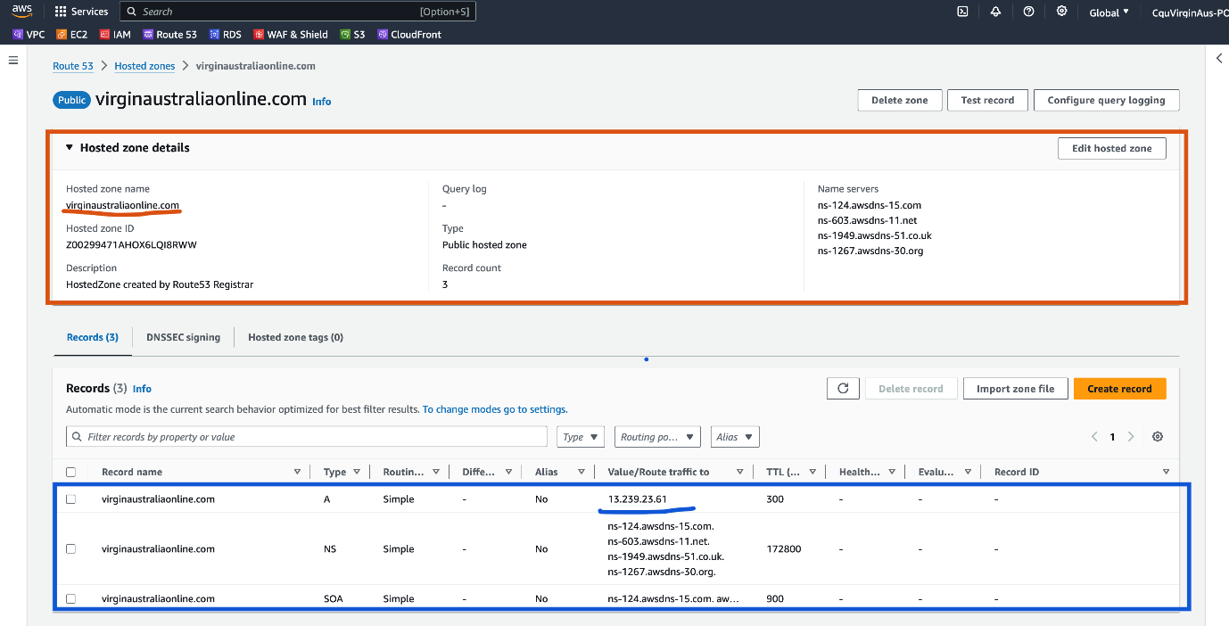

I have created VPC and subnets required and configure them with route tables to ensure public and private subnets through Internet gateway and NAT Gateway configuration.

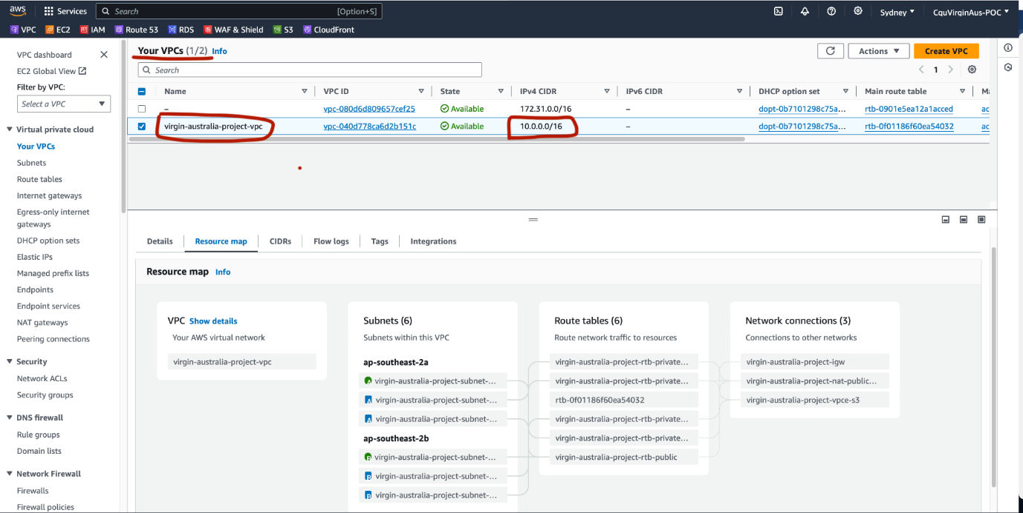

Public and Private Subnets

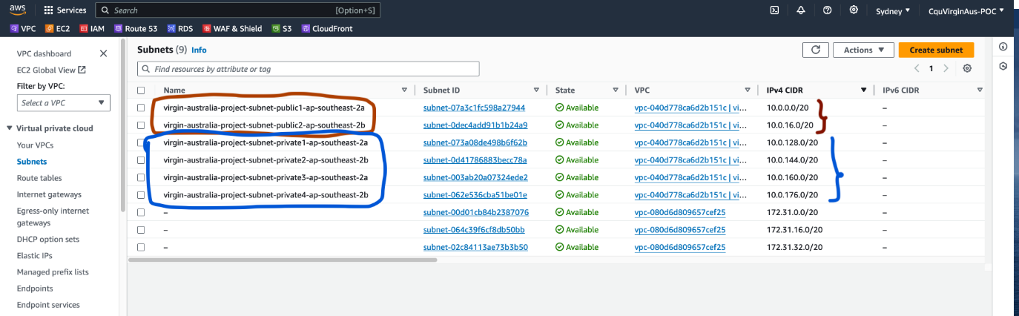

I had the responsibility of implementing security groups required for various components in the architecture.

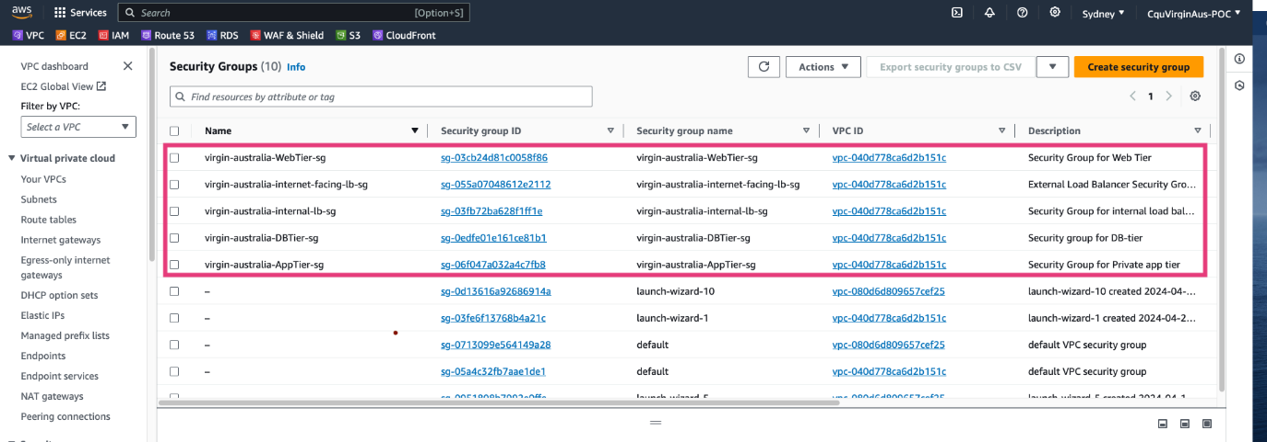

I had learned about DNS configuration and how this impacts accessibility of application. Additionally configuring the security groups was critical aspect of ensuring security, for the purpose of testing and providing access to public inbound rules for security group of web-application has been allowed to 0.0.0.0/0 once the load balancer is setup, we will refine these rules and narrow down the access. Overall, I am confident that I have gained enough understanding of DNS management and adding A records to forwards the traffic. Configuring the Route Tables to allow access of internet to subnets making them public and private. Restricting access through inbound and outbound rules in Security group.

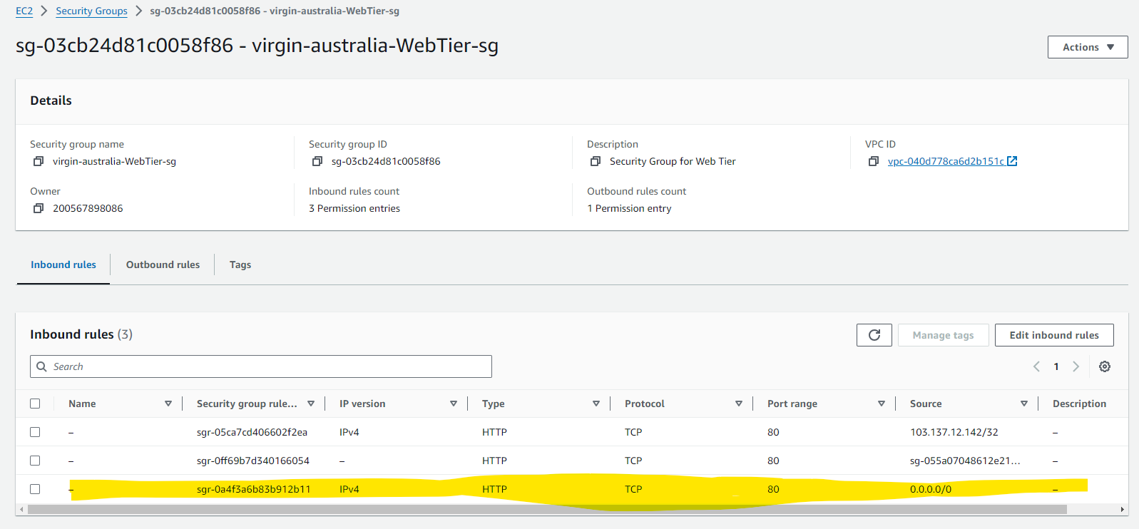

# 2. Technical Contribution to the tasks

My contribution to the tasks has involved learning and implementing DNS and configuring Route53 hosted zone with DNS records and A record to forward the incoming traffic to [www.virginaustraliaonline.com](http://www.virginaustraliaonline.com) .   
I have registered a new domain name for current project on Virgin Australia using Route53 service, a public hosted zone has been created with Name server records and SOA records. Additionally, I have configured one A-record for routing the incoming traffic to webserver hosting the sample web application. Moreover, I have configured the inbound and outbound rules of the security group to control the access to application components. The internet gateway and NAT Gateway required for the internet access, I have ensured that configuration adhere to best practices and security standards, which will contribute to overall robustness of the architecture.

# 3. Contribution of task to my future goals

I have gained hands-on experience by completing these tasks on DNS management, VPC creation and Security group configuration on AWS. These skills are highly relevant in the area of cloud computing and infrastructure management. As I aspire to pursue my career as Cloud architect or networking and security engineer, these skills will strengthen my fundamentals of cloud infrastructure management and aligned with my future goals to enable me to become skilled cloud professional.

The next priority tasks which include SSL certificate registration for secure communication and CDN. This will help to understand how a secure connection is established between website and client, through CDN configuration I will gain the knowledge of how contents of website can be served faster. Overall, the practical implementation of these steps and integration of various components will boost my confidence and skills on cloud services and motive to explore the options best available alternatives to each of these services in other cloud providers. I believe with this enthusiasm I will expand my scope of learning from AWS cloud to multi cloud such as Azure Cloud, Google Cloud etc to work in wider platforms.

# 4. Tasks Progress

**Week-6:** I have registered a free tier account on AWS, which allowed me to explore the various services used in our project. Deployed some sample services and tested to gain hands-on experience.

**Week-7:** I have implemented the assigned tasks step-1, step-2, step-3, step-4. During the implementation I have ensured best practices in DNS registration on Route53. Creation of public Hosted zone in Route53, deploying VPC along with 6 subnets two for public subnets and 4 for private subnets. Creation IGW and NAT Gateway and configuring the RouteTables to ensure the access of internet through IGW and NAT Gateway. Creation of Security groups for various components.

# 5. Challenges and approaches to resolve

* **Challenges**: While implementing DNS registration, encountered issues in routing the traffic to webserver and accessing the website from internet
* **Approach to resolve**: Referred the AWS official and other blogs on internet to find the resolution and created A-records and allowed the security group inbound rule to 0.0.0.0/0 to allow access form internet.

# 6. Priority Tasks for next phase

The next priority tasks in my queue are Step-11 and Step-12.

* Implementation of SSL certificate to enable secure communication between clients and the webserver which will enhance security posture. To update the Route53 hosted zone to include SSL certificate for domain verification.
* Configure Content Delivery Network to enhance the accessibility of static contents of the website. CDN will cache the static content such as images, files at edge locations to ensure fast access of the websites.

# 7. E-portfolio

* GitHub Link: <https://github.com/SuhailCloudTech/COIT20265-3tier-web-application-repo>
* Portfolio URL: <https://portfolium.com/entry/coit20265-project-individual-progress>
* Demo Website URL: <http://www.virginaustraliaonline.com/>